** GLOBAL ACADEMY OF TECHNOLOGY**

Approved by AICTE, New Delhi, Recognized by the Govt. of Karnataka

Autonomous Institute affiliated to VTU, Belagavi,

NAAC Accredited with ‘A’ Grade

Ideal Homes Township, Rajarajeshwari Nagar, Bengaluru-98

**Department of Computer Science and Engineering**

**(Accredited by NBA 2019-2022)**

A

Mini Project Report on

**“Face Recognition Attendance Management System”**

***Submitted in partial fulfillment of Database Management System Laboratory***

***with Mini project (20CSEL48) of IV th semester***

**Bachelor of Engineering**

**In**

**Computer Science and Engineering**

***Submitted by***

**MAHESH N D USN: 1GA20CS073**

**N DHANVINA USN: 1GA20CS085**

**Under the Guidance of**

Lab Incharge **Lab Incharge**

Assistant Professor Assistant Professor

**GLOBAL ACADEMY OF TECHNOLOGY**

**Department of Computer Science and Engineering**



**CERTIFICATE**

Certified that the IV Semester Mini Project in Database Management System with Mini project Entitled **“Face Recognition Attendance Management System”** carried out by **MAHESH N D** and **N DHANVINA** is submitted in partial fulfillment for the award of the **Bachelor of Engineering** in Computer Science and Engineeringduring the year 2021-2022.The Database Management System with Mini project report has been approved as it satisfies the academic requirements in respect of the mini project work prescribed for the said degree.

**Dr. Bhagyashri R Hanji**

Professor & Head,

Dept of CSE,

GAT, Bengaluru.

**Lab Incharge**

Assistant Professor,

Dept of CSE,

GAT, Bengaluru.

**Lab Incharge**

Assistant Professor,

Dept of CSE,

GAT, Bengaluru.

Name of the Examiners Signature with date



2.

**GLOBAL ACADEMY OF TECHNOLOGY**

**Department of Computer Science and Engineering**

**(Accredited by NBA 2019-2022)**

**Rajarajeshwari Nagar, Bengaluru – 560 098**

**DECLARATION**

We, MAHESH N D, bearing USN 1GA20CS073 and N DHANVINA, bearing USN 1GA20CS085 students of Fourth Semester B.E, Department of Computer Science and Engineering, Global Academy of Technology, Rajarajeshwarinagar Bengaluru, declare that the Mini Project entitled “**Face Recognition Attendance Management System**” has been carried out by us and submitted in partial fulfillment of the course requirements for the award of degree in Bachelor of Engineering in Computer Science and Engineering for the academic year 2021-2022.

**………………. ……………….**

**MAHESH N D N DHANVINA**

**( 1GA20CS073) (1GA20CS085)**

Place: Bengaluru

Date: 10-09-2022

**ABSTRACT**

Facial Recognition is a technology of bio-metrics has been used in many areas like security

systems, human machine interaction and image processing techniques.The conventional method in the institutions are the faculty passes an attendance sheet or make roll calls to mark attendance of the student, which sometimes disturbs discipline of the class and the sheet further goes to the admin department,which is then updated to an excel sheet. This process is quite hectic and time consuming. The proposed solution for the current problem is through automation of attendance system using face recognition. This project describes the method of detection and

recognition the face in real time. Here, the camera is fixed in the classroom will capture the image. The faces in the images are detected and then recognized with the database after which the attendance is marked. The system used to calculate attendance automatically by recognizing the facial dimensions of all faces in an image and then marks attendance.The system maintains a track of student attendance and makes predictions on future attendance trends.

Maintaining attendance is very important in all the educational institutions. But it’s the most difficult task in various institutions. Every institution has its own method of attendance marking system. Some institutions use the attendance sheet, RFID reader,keystroke or biometric fingerprint techniques. The attendance sheet method has difficulty to maintaining and it has some manual errors.Computers can detect a person's face using a digital image or video. It may be done by comparing the image captured in the real time with the database image. The facial characters obtained from a real time image is to be

compared with the facial characters of the database image stored. The automated attendance management system gives a facility to the faculties to reduce the burden in taking attendance. This system takes the attendance automatically using face recognition. However, it may be difficult to estimate the attendance using each result of face recognition independently because of the high the face detection rate.Further more a student may now also be able to predict future attendance trends using Linear Regression.

Face recognition has potential applications in security control,office automation, prevention of fraud, automatic personalization of environments,

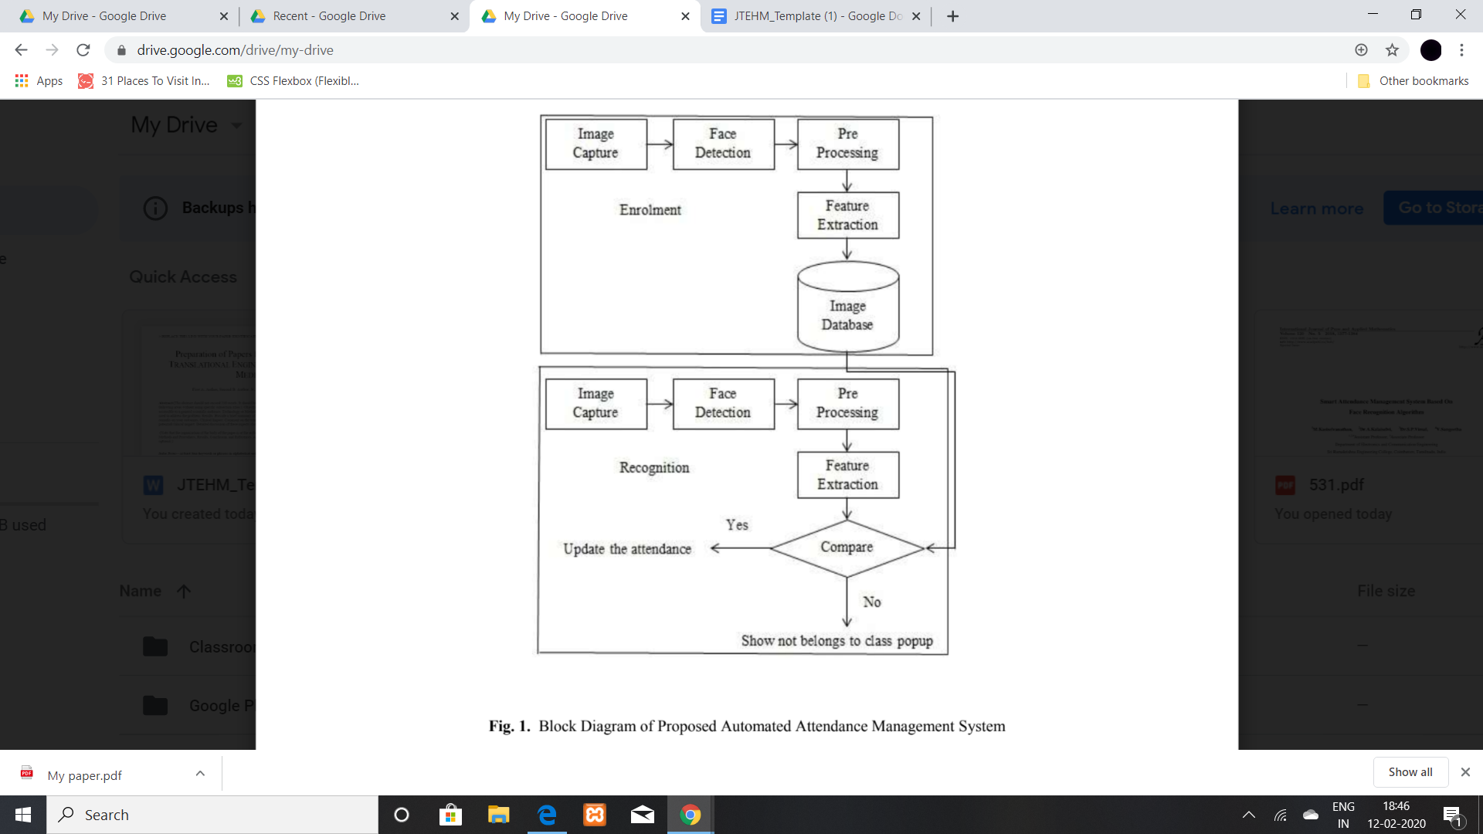

**ACKNOWLEDGEMENT**

The satisfaction and euphoria that accompany the successful completion of any task would be incomplete without the mention of the people who made it possible and whose constant encouragement and guidance crowned our efforts with success.

We consider ourselves proud, to be part of **Global Academy of Technology** family, the institution which stood by our way in endeavors.

We express our deep and sincere thanks to our Principal **Dr. N. Ranapratap Reddy** for his support.

We are grateful to **Dr. Bhagyashri R Hanji** , Professor and HOD, Dept of CSE who is source of inspiration and of invaluable help in channelizing my efforts in right direction.

We wish to thank our internal guide **Dr.Manjula.K,** Associate Professor**,** **Mrs.Snigdha Sen,** Assistant Professor and **Mrs. Reshma D’souza,** Assistant Professor, Dept of CSE for guiding and correcting various documents with attention and care. They has taken lot of pain to go through the document and make necessary corrections as and when needed.

We would like to thank the faculty members and supporting staff of the Department of CSE, GAT for providing all the support for completing the Project work.

Finally, we are grateful to our parents and friends for their unconditional support and help during our Project work.

**N DHANVINA 1GA20CS085**

**MAHESH N D 1GA20CS073**

**TABLE OF CONTENTS**

|  |  |  |  |
| --- | --- | --- | --- |
| **Chapter No.** |  | **ABSTRACT** | I |
|  |  | LIST OF FIGURES | V |
|  |  | LIST OF TABLES | VI |
| **1.** |  | **INTRODUCTION** |  |
|  | 1.1 | INTRODUCTION TO SQL | 5 |
|  | 1.2 | INTRODUCTION TO FRONTEND SOFTWARE | 6 |
|  | 1.3 | PROJECT REPORT OUTLINE | 7 |
| **2.** |  | **REQUIREMENT SPECIFICATION** |  |
|  | 2.1 | SOFTWARE REQUIREMENTS | 7 |
|  | 2.2 | HARDWARE REQUIREMENTS | 8 |
| **3.** |  | **OBJECTIVE OF THE PROJECT** | 9 |
| **4.** |  | **IMPLEMENTATION** | 10 |
|  | 4.1 | ER DIAGRAM | 10 |
|  | 4.2 | MAPPING OF ER DIAGRAM TO SCHEMA DIAGRAM | 11 |
|  | 4.3 | MAPPING OF THE ER SCHEMA TO RELATIONS | 12 |
|  | 4.4 | CREATION OF TABLES | 13-14 |
|  | 4.5 | INSERTION OF TUPLES | 15-16 |
|  | 4.6 | CREATION OF TRIGGERS | 17 |
|  | 4.7 | CREATION OF STORED PROCEDURES | 17 |
| **5.** |  | **FRONT END DESIGN** | **18** |
|  | 5.1 | FRONT END CODE | 20-22 |
|  | 5.2 | CONNECTIVITY TO DATABASE | 19 |
| **6.** |  | **TESTING** | 23 |
|  | 6.1 | TEST CASES FOR THE PROJECT | 23 |
| **7.** |  | **RESULTS** | **24** |
|  | 7.1 | SNAPSHOTS | 24-25 |
| **8.** |  | **CONCLUSION** | 26 |
| **9.** |  | **REFERENCES** | 26 |

**LIST OF FIGURES**

|  |  |  |
| --- | --- | --- |
| **Figure No.** | **Title** | **Page No.** |
| 4.1 | ER diagram | 10 |
| 4.2 | Mapping of ER diagram to schema diagram | 11 |
| 4.3 | Mapping of ER diagram to Relation | 12 |
| 7.1 | Login page | 24 |
| 7.2 | New Parcel | 24 |
| 7.3 | Parcel list | 25 |
| 7.4 | Branch list | 25 |

**LIST OF TABLES**

|  |  |  |
| --- | --- | --- |
| **Table No.** | **Title** | **Page No.** |
| 6.1 | Test cases for the project | 24 |

**CHAPTER 1**

**INTRODUCTION**

In modern times, Automatic Face recognition have implemented with different types of algorithms. In (AFR) technologies have seen dramatic improvements in performance over the last few years. There are two reasons for this trend; the first is for saving the time in the classroom and accuracy in attendance will be maintained, and the second is availability of advanced technology it is more useful for the future generation. In simple words, it was a computer implementation for recognizing automatically whether the student is present in the classroom or not with the help of still image or video frame. Attendance is one of the important aspects in the classroom. At the beginning and ending of the section, the teacher should check out the students presence in the class generally teachers take the attendance and note done in the register, but it may appear that miss someone and students any give attendance multiple times.so to avoid this type. We proposed an automatic attendance management system. It was completely based on face recognition and the face detection. This both detection and recognition will efficiently mark attendance

Attendance marking are necessary to conclude and authentication of students as well as employees of organization. Many researches have been done in this area to improve and replace the traditional system of attendance by face recognition technology. Face recognition-based attendance marking system provides several advantages over conventional method of taking attendance in class. A number of algorithms for face recognition have been proposed but most of these works deal with only single image of a face at a time. By continuously observing of face information, proposed approach can solve the problem of the face detection and improve the accuracy of face recognition.This system aims to detect the position of each student and capture an image and then analyse the given image of class and mark attendance of all faces present in that image.

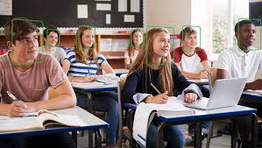

Figure 1 describes the working principle of the proposed

methodology for automatic attendance marking system.

***Face Detection***

We make use of a Haar Cascade is basically a classifier which is used to detect particular objects from the source. The haarcascade frontal face default is a haar cascade designed by OpenCV to detect the frontal face. A Haar Cascade works by training the cascade on thousands of negative images with the positive image superimposed on it. The haar cascade is capable of detecting features from the source.

***Face recognition***

With the facial images already extracted, cropped, re-sized and usually converted to grayscale, the face recognition algorithm is responsible for finding characteristics which best describe the image To perform this task we use a LBPH(local binary patter histogram) recognizer.

**CHAPTER 1**

**INTRODUCTION**

**1.1 INTRODUCTION TO SQL**

The Structured Query Language (SQL) is the language of databases. All modern relational databases, including Access, FileMaker Pro, Microsoft SQL Server, and Oracle use SQL as their basic building block. In fact, it’s often the only way that you can interact with the database itself. All the graphical user interfaces that provide data entry and manipulation functionality are nothing more than SQL translators. They take the actions you perform graphically and convert them to SQL commands understood by the database.

* + 1. **SQL Command**

SQL provides a wide range of statements, of which SELECT is just one. Here are some examples of other common SQL statements:

SQL INSERT and SQL DELETE: Inserts or deletes a record from a table SQL UPDATE: Modifies records in a table

SQL CREATE and SQL DROP: Creates or deletes a table

In addition to these SQL statements, you can use SQL clauses, among them the WHERE clause used in the previous examples. These clauses serve to refine the type of data to act on. In addition to the WHERE clause, here are other commonly used clauses:

AND or OR

Combine multiple conditions to refine a SQL statement

LIKE: Compares a value to similar values using a wildcard

ORDER BY: Sorts data in ascending or descending order

If you are interested in further exploring SQL, SQL Fundamentals is a multipart tutorial that explores the components and aspects of SQL in more detail.

* 1. **INTRODUCTION TO FRONT END SOFTWARE**

Frontend: which is markup showed by clients or users browsers, and for doing this we should use HTML (Hyper Text Markup Language), it just shows some elements for users and doesn't run any functions. When you go to a specific URL, your request is sent to your desired server and it'll render for your HTML of the site, in fact, the server runs any server-side functions.

The Front-End used in this project is HTML along with the CSS and JS language.

* HTML stands for Hyper Text Markup Language
* HTML is the standard markup language for creating Web pages.
* HTML describes the structure of Web pages using markup
* HTML elements are the building blocks of HTML pages
* HTML elements are represented by tags
* HTML tags label pieces of content such as "heading", "paragraph", "table", and so on
* Browsers do not display the HTML tags, but use them to render the content of the page

**Connectivity (front end and Back end):**

**PHP is an amazing and popular language!**

It is powerful enough to be at the core of the biggest blogging system on the web (Word Press)! It is deep enough to run the largest social network (Facebook)! It is also easy enough to be a beginner's first server-side language!

* PHP is an acronym for "PHP: Hypertext Pre-processor"
* PHP is a widely used, open-source scripting language
* PHP scripts are executed on the server
* PHP is free to download and use
* PHP files can contain text, HTML, CSS, JavaScript, and PHP code
* PHP code are executed on the server, and the result is returned to the browser as plain HTML
* With PHP you are not limited to output HTML. You can output images, PDF files, and even flash movies. You can also output any text, such as XHTML and XML
  1. **PROJECT REPORT OUTLINE**

**The report is arranged in the following way:**

**Chapter 1:** Introduction to SQL about its database, SQL query, interpreting SQL statements, AND or OR and range if SQL statements

**Chapter 2:** requirement specification of hardware and software

**Chapter 3:** Objective of the Project, design of project and developing

**Chapter 4:** Implementation of ER diagram and it’s description

**Chapter 5:** Front End Design, connecting to database using PHP, Front end code of the Project

**Chapter 6:** Testing of project by different cases, it’s process and testing objectives

**Chapter 7:** Outcome of the Project

**CHAPTER 2**

**REQUIREMENT SPECIFICATION**

The requirement analysis specifies the requirements needed to develop a graphic project. In this phase, we collect the requirements needed for designing the project. The requirements collected are then analyzed and carried to the next phase.

**2.1 SOFTWARE REQUIREMENTS**

1. **Operating System :** Windows7 or higher
2. **Database :** MySQL
3. **Scripting Language :** Python
4. **Backend development :** PHP
5. **Tools :** XamppServer

**2.2 HARDWARE REQUIREMENTS**

1. **Processor :** Pentium IV or above

1. **RAM :** 2.00GB or more
2. **Hard Disk** **:** 5GB or more

4. **Input device** **:** Keyboard, Camera

5. **Output device :** Laptop Display Screen

**CHAPTER 3**

**FEATURES**

This project can be divided into three major parts:

1. **Registration**
2. **Attendance Marking**

3. **CRUD operation**

4. **Prediction**

**REGISTRATION:**

**Step 1:**

Registration in this project consists of a student and admin entering the required details:-

**Student :**

● Name

● Registration number

**Admin :**

● Name

● Phone number

● E-mail ID

● Password

● Confirm Password

These details are then fed into our local database using python module

‘mysql.connector’, this allows us to connect to the given database.

Our database name “students” contains table “student” and “registration_details” which stores each student and admin information in the respective column .We have made use of XAMP to create a local server and provide us with DBMS functionality.

**Attendance Marking**

**Step 2:**

After the given steps are complete the program starts collecting samples of each students face,this is done using the library CV2.These samples are images of the students face and contain his ID and sample number,these samples are stored in the folder “TrainingImages” of .jpg files. All students must complete registration phase before moving ahead.

**CRUD operation**

**Step 3:**

**Create**

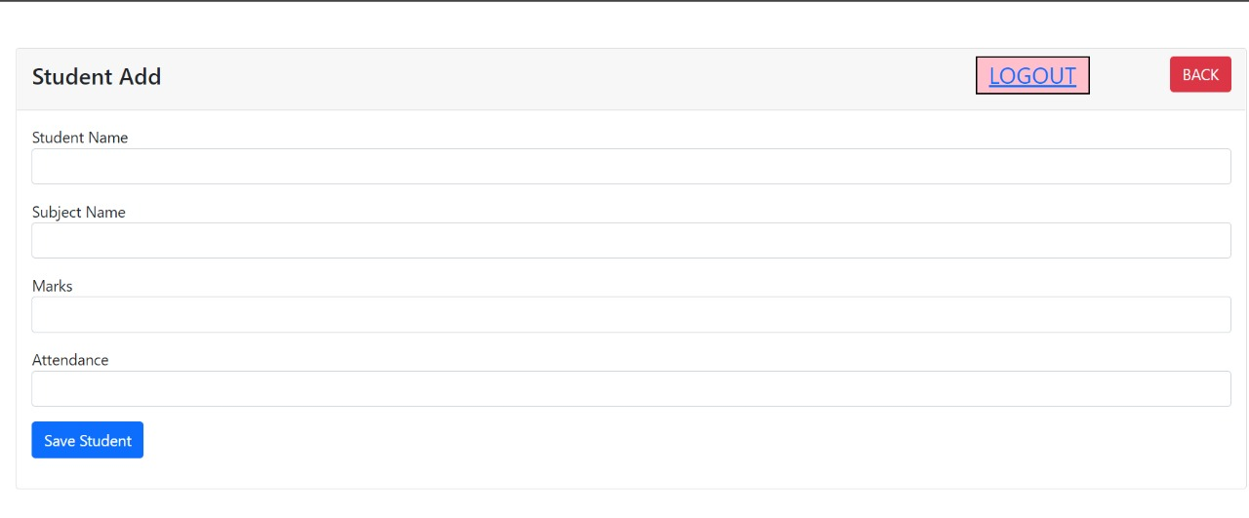

**Read / View**

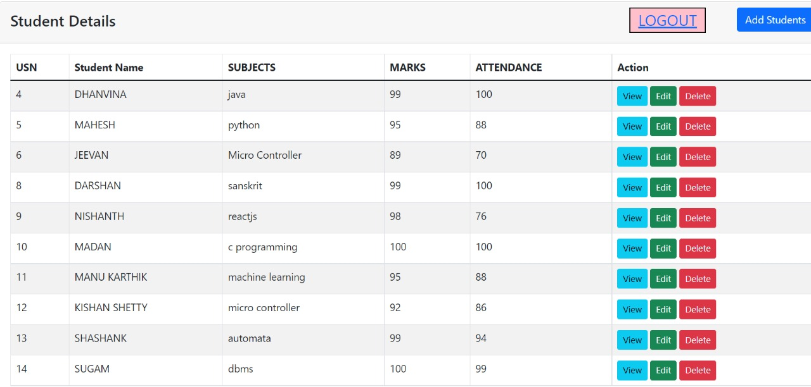

**Update**

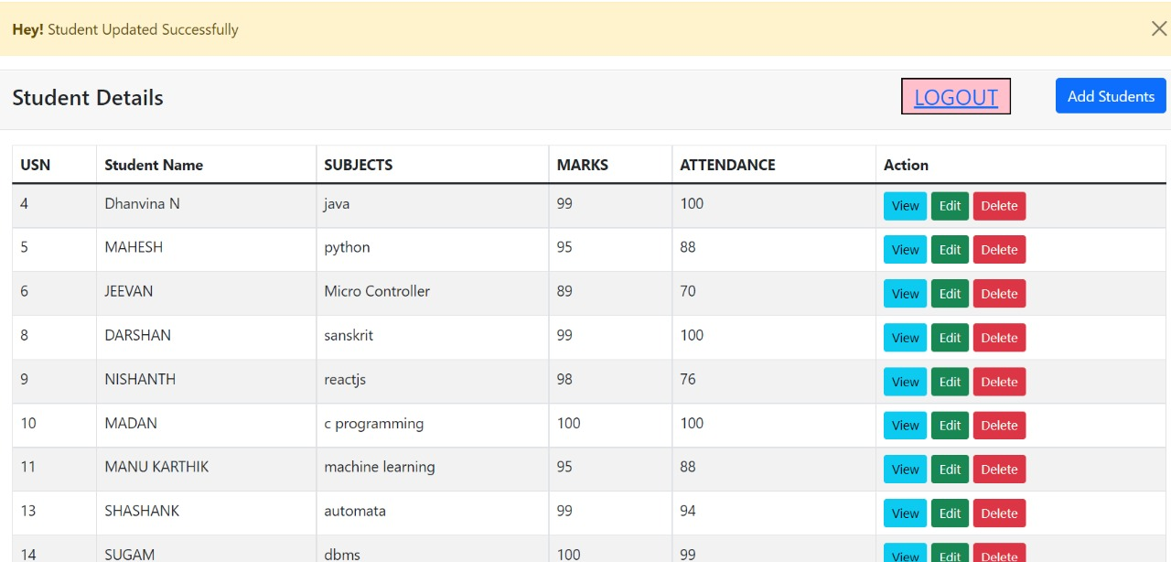

**Delete**

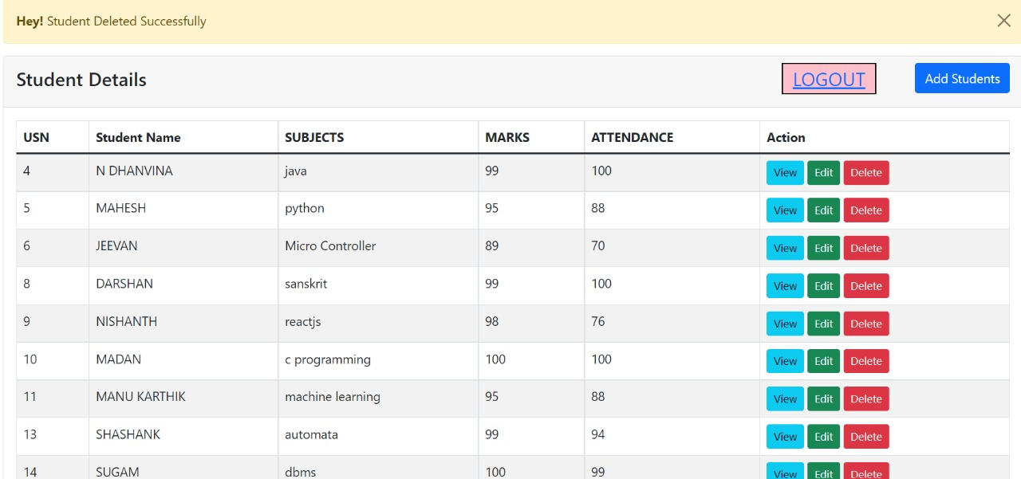

**CHAPTER 4**

**IMPLEMENTATION**

**4.1 ER DIAGRAM**

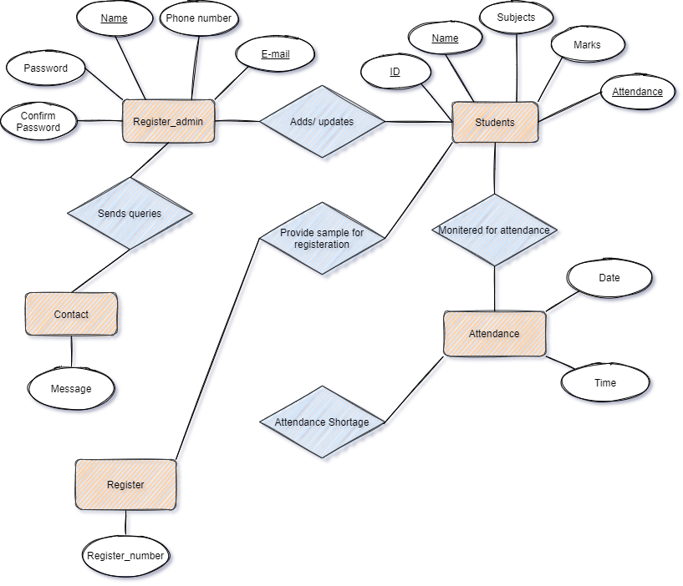

**4.2 MAPPING OF ER DIAGRAM TO SCHEMA DIAGRAM**

**Mapping :** The conceptual/internal mapping defines the correspondence between the conceptual view and the store database. It specifies how conceptual record and fields are represented at the internal level. There could be one mapping between conceptual and internal levels

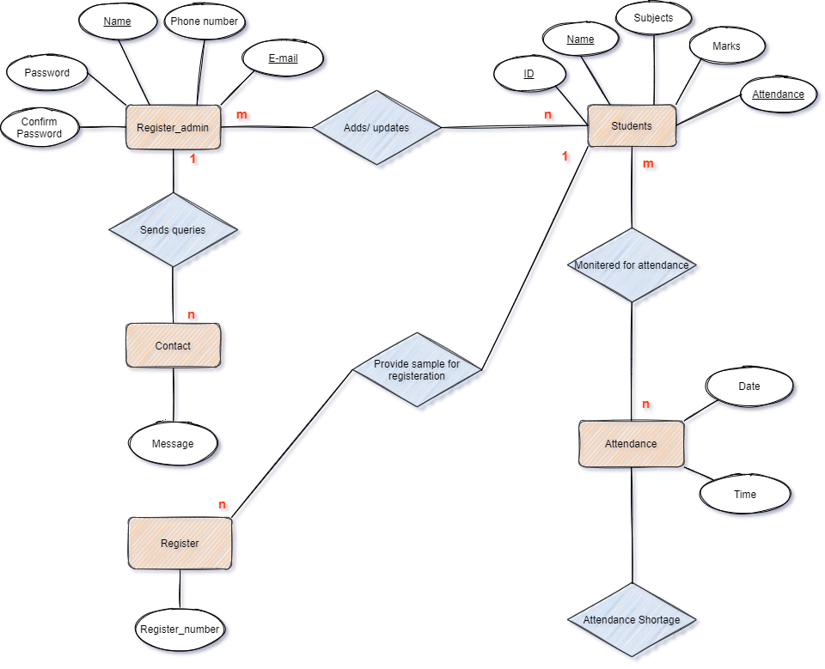

**4.3 MAPPING OF THE ER SCHEMA TO RELATIONS**

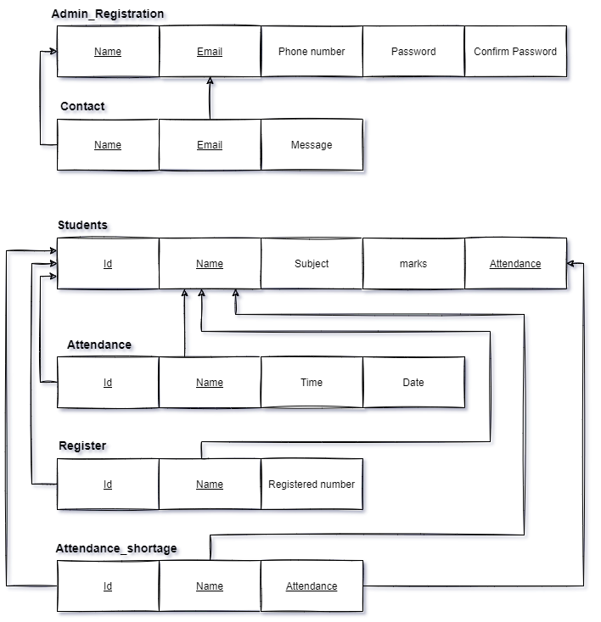 **4.4 CREATION OF TABLES**

**Table Creation**

**STUDENT Table**

CREATE TABLE STUDENT

(

Id int NOT NULL AUTO_INCREMENT PRIMARY KEY,

Name VARCHAR(191) NOT NULL,

Subject VARCHAR(191) NOT NULL,

Marks VARCHAR(191) NOT NULL,

Attendance VARCHAR(191) NOT NULL

);

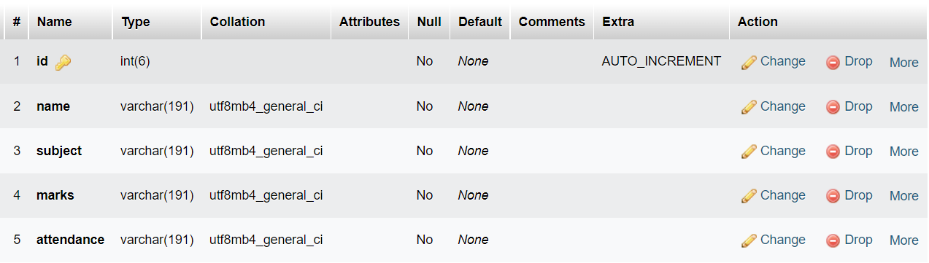

**REGISTER_DETAILS Table**

CREATE TABLE REGISTER_DETAILS

(

Name VARCHAR(20) NOT NULL PRIMARY KEY,

Phone_number BIGINT(20) ) NOT NULL,

Email VARCHAR(20) NOT NULL,

Password VARCHAR(20) NOT NULL,

Repassword VARCHAR(20) NOT NULL

);

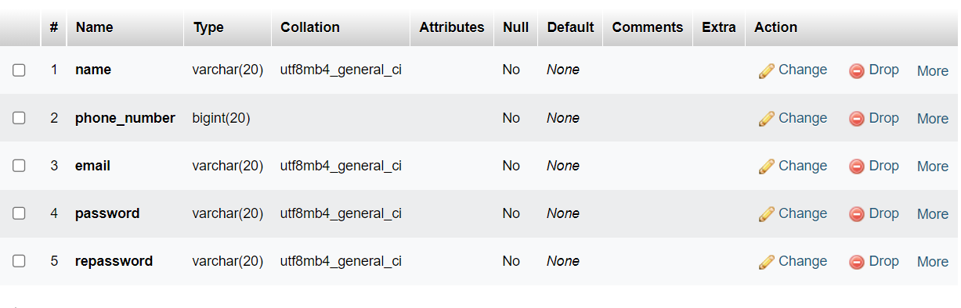

**CONTACT Table**

CREATE TABLE CONTACT

(

Name VARCHAR(20) NOT NULL PRIMARY KEY,

Email VARCHAR(20) NOT NULL,

Message VARCHAR(20) NOT NULL

);

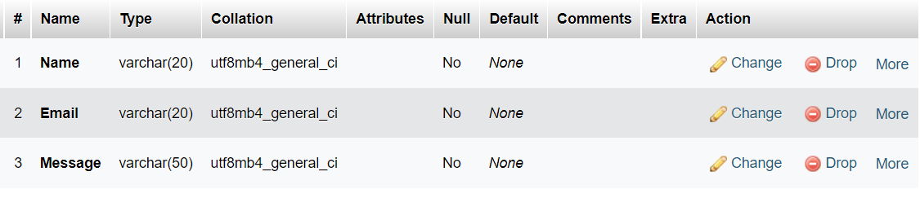

**ATTENDANCE Table**

CREATE TABLE ATTENDANCE

(

COL1 VARCHAR(2) PRIMARY KEY,

COL2 VARCHAR(8),

COL3 VARCHAR(10) ,

COL4 VARCHAR(8)

);

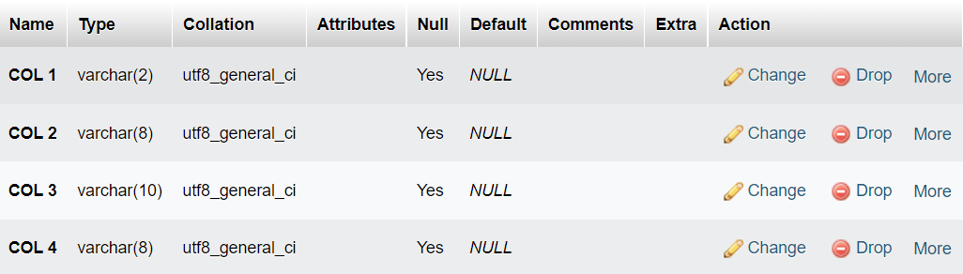

**CONTACT Table**

CREATE TABLE CONTACT

(

Id int NOT NULL AUTO_INCREMENT PRIMARY KEY,

Name VARCHAR(191) NOT NULL,

Subject VARCHAR(191) NOT NULL,

Attendance VARCHAR(191) NOT NULL

);

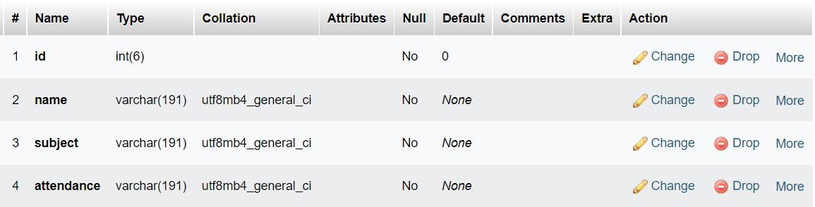

**4.5 INSERTION OF TUPLES**

**Students Table:**

INSERT INTO Students (`id`, `name`, `subject`, `marks`, `attendance`) VALUES

(4, 'Dhanvina N', 'java', 99, 100),

(5, 'Mahesh', 'python', 95, 74),

(6, 'Jeevan', 'Micro controller', 89, 70),

(8, 'Darshan', 'sanskrit', 99, 100),

(9, 'Nishanth', 'reactjs', 99, 100),

(10, 'madan', 'c programming', 100, 100),

(11, 'manu karthik', 'machine learning', 95, 88),

(13, 'shashank', 'automata', 99, 94),

(14, 'sugam', 'dbms', 100, 99);

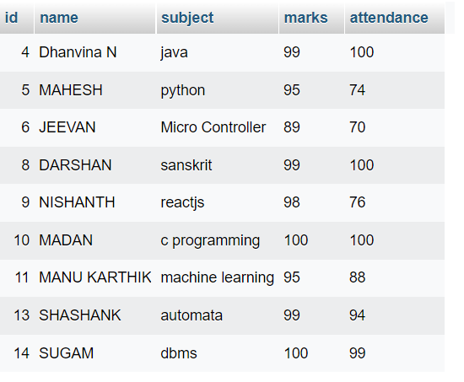

**Register_details Table:**

INSERT INTO Register_details (`name`, `phone_number`, `email`, `password`, `Repassword`) VALUES

('Mahesh', 5467567575, 'mahi@gmail.com', 'mahi123', 'mahi123'),

('Jishnu', 785634782, 'jishnu@gmail.com', '123', '123'),

('Dhanvina', 587358735, 'danny@gmail.com', 'danny123', 'danny123'),

('Mahesh', 6797892542, 'mahesh@gmail.com', '123', '123'),

('Mahesh', 6871576254, 'uihgQJB@HLKAS.com', '123', '123'),

('Darshan', 7653822342, 'darshan@gmail.com', '123456', '123456');

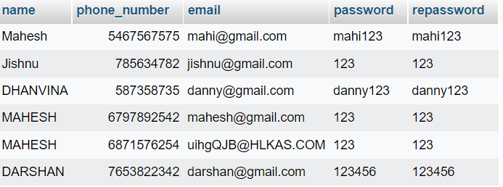

**Contact Table:**

INSERT INTO Contact (`Name`, `Email`, `Message`) VALUES

('Mahesh', 'Mahi@gmail.com', 'Hi guys'),

('Mahesh', 'Mahi@gmail.com', 'No Query at all'),

('Dhanvina', 'danny@gmail.com', 'Facing issue with login'),

('Nishanth', 'nishanth@gmail.com', ''Facing issue with registering'),

('Jeevan', 'jeevan@gmail.com', 'having trouble in accessing datas');

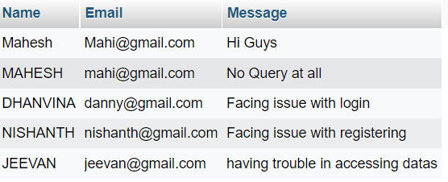

**Attendance Table:**

INSERT INTO Attendance (`id`, `Name`, `Date`, `Time`) VALUES

('2', 'mahesh', 07-09-2022, 11:37:39),

('3', 'dhanvina', 07-09-2022, 11:38:39),

('4', 'darshan', 07-09-2022, 11:39:39),

('5', 'nishanth', 07-09-2022, 11:40:39);

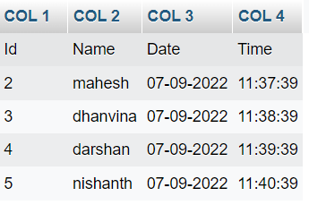

**Shortage_attendance Table :**

INSERT INTO Shortage_attendance (`id`, `name`, `subject`, `attendance`) VALUES

('5', 'mahesh', 'python', 74),

('6', 'jeevan', 'micro controller', 70);

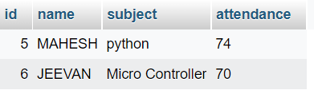

**4.6 Creation of triggers**

CREATE TRIGGER ‘upper_case; BEFORE INSERT ON ‘users’ FOR EACH ROW BEGIN

SET NEW.f_anme = UPPER(NEW.f_name);

END

**4.7 CREATION OF STORED PROCEDURES**

DELIMETER $$

CREATE DEFINER =’root@’localhost’PROCEDURE’storedprocedure’()

NO SQL

SELECT id, name, subject, marks, attendance from Students$$

DELIMETER;

#### **FRONT END DESIGN**

#### **5.2 CONNECTIVITY TO DATABASE**

* Most Web Applications :- Retrieve information from a database to alter their on-screen display-Store user data such as orders, tracking, credit card, etc. in a database.
* Permits them to adapt individual users, and provide fresh changing content.

**PHP: Built-in Database Access**

* PHP provides built in database connectivity for a wide range of databases - MySQL, PostgreSQL, Oracle, Berkeley DB, Informix, mSQL, Lotus Notes, and more - Starting support for a specific database may involve PHP configuration steps.
* Another advantage of using a programming language that has been designed for the creation of web apps.

**High-Level Process of Using MySQL from PHP**

* Create a database connection.
* Select database you wish to use.
* Perform a SQL query.
* Do something processing on query results.
* Close database connection

##### **SELECTING A DATABASE**

* mysql_select_db() - Pass it the database name.
* Related :- mysql_list_dbs()
* List databases available - Mysql_list_tables() ● List database tables available.

##### **PERFORM SQL QUERY**

* Create query string - $query = ‘SQL formatted string’ - $query = ‘SELECT*FROM table’.
* Submit query to database for processing - $result = mysql_query($query); - For UPDATE, DELETE, DROP, etc, returns TRUE or FALSE - For SELECT, SHOW, DESCRIBE or EXPLAIN, $result is an identifier for the results, and does not contain the results themselves.
* $result is called a “resource” in this case.

##### **CREATING DATABASE CONNECTION**

● Use either mysql_connect or mysql_pconnect to create database connection

* mysql_connect: connection is closed at the end of script (end of page).
* mysql_pconnect: creates persistent connection
* connection remains even after the end of the page
* parameters
  + Server - hostname of the server.
  + Username - username on the database.
  + Password - password on the database - New link (mysql_connect only).
  + reuse database connection created by previous call to mysql_connect - Client Flags.

* MYSQL_CLIENT_SSL :: Use SSL
* MYSQL_CLIENT_COMPRESS :: Compress data sent to MySQL.

##### **CLOSING DATABASE CONNECTION**

● mysql_close()

* closes database connection.
* Only works for connections opened with mysql_connect().
* Connections opened with mysql_pconnect() ignore this call.
* Often not necessary to call this, as connections created by mysql_connect are closed at the end of the script anyway.

#### **5.1 FRONT END CODE**

Today, technology has become significant for each and everything for human lives, as it makes things better for living such mobile phones, computers, and tablets making huge convenience. This technology helps business to promote and avail for 24*7 all the time.

The advanced technology has benefits for both customer and business for several reasons. At the attendance point of view, face recognition helping to identify the face of human by using biometrics to map facial dimensions from an image of a person. The technology helps to compare data with a stored database to identify the concerned image.The face recognition technology is expected to reach all areas to prevent fraud and deceptions methods in the work. One of the reasons why face recognition has significance in every area is due to complicated issues like private areas.

**HTML CODE OF HOME PAGE :**

<!DOCTYPE html>

<html lang="en">

<head>

    <title>website</title>

    <link rel="stylesheet" href="style.css">

</head>

<body>

    <div class="main">

        <div class="navbar">

            <div class="menu">

                <ul>

                <li><a href="#">HOME</a></li>

                <li><a href="login.html">LOGIN</a></li>

                <li><a href="register.html">REGISTER</a></li>

                <li><a href="about.html">ABOUT</a></li>

                <li><a href="contact.html">CONTACT US</a></li>

                </ul>

            </div>

        </div>

        <div class="content"><br>

            <h1><br><span>FACE RECOGNITION <br>ATTENDANCE</span><br>MANAGEMENT SYSTEM</h1>

            <p class="par"></p>

            <a href="contact.html"><button class="cn" style="font-size: 20px;">Contact Us</button></a>

        </div>

    </div>

</body>

</html>

**CSS CODE OF HOME PAGE :**

*{

    margin: 0;

    padding: 0;

}

.main{

    width: 100%;

    background: linear-gradient(to top,rgba(0,0,0,0.5)20%,rgba(0,0,0,0.5)20%),url(image/sunset.jfif);

    background-position: center;

    background-size: cover;

    height: 100vh;

}

.navbar{

    width: 1200px;

    height: 75px;

    margin: auto;

}

.menu{

    width: 400px;

    float: left;

    height: 70px;

    color: red;

}

ul{

    float: left;

    display: flex;

    justify-content: center;

    align-items: center;

}

ul li{

    float: left;

    list-style: none;

    margin-left: 80px ;

    margin-top: 27px;

    font-size: 35px;

}

ul li a{

    text-decoration: none;

    color: rgb(233, 237, 240);

    font-family: Arial;

    font-weight: bold;

    transition: 1 sec ease-in-out;

}

ul li a:hover{

    color: red;

}

.content{

    width: 1200px;

    height: auto;

    margin: auto;

    color: #fff;

    position: relative;

    margin-top: 25px;

}

.content .par{

    padding-left: 20px;

    padding-bottom: 25px;

    font-family: arial;

    letter-spacing: 1.2px;

    line-height: 30px;

}

.content h1{

    font-family: 'Times New Roman';

    font-size: 50px;

    padding-left: 20px;

    margin-top: 9%;

    letter-spacing: 2px;

}

.content .cn{

    width: 160px;

    height: 40px;

    background: orange;

    border: none;

    margin-bottom: 10px;

    margin-left: 20px;

    font-size: 18px;

    border-radius: 10px;

    cursor: pointer;

    transition: 0.2s ease;

}

.content:hover{

    color: rgb(1, 21, 249);

    font-weight: bold;

}

.content .cn{

    text-decoration: none;

    color: #000;

    transition: 1s ease;

}

.cn:hover{

    background-color: #fff;

}

.content span{

    color: chartreuse;

    font-size: 60px;

}

**PHP CODE OF LOGIN PAGE :**

<?php

$email = $_POST['email'];

$password = $_POST['password'];

$con = new mysqli("localhost","root","","database12");

if($con->connect_error){

    die("Failed to connect : ".$con->connect_error);

} else {

    $stmt = $con->prepare("Select * from register_details where email = ?");

    $stmt->bind_param("s",$email);

    $stmt->execute();

    $stmt_result = $stmt->get_result();

    if($stmt_result->num_rows > 0){

        $data = $stmt_result->fetch_assoc();

        if($data['password'] === $password){

            echo '<h2>Login Succesfully</h2>';

            header("Location: profile.html");

        } else {

            echo "<h2>Invalid Email or password</h2>";

        }

    } else {

        echo "<h2>Invalid Email or password</h2>";

    }

}

?

**CHAPTER 6**

### **TESTING**

**6.1 TEST CASES**

The test cases provided here test the most important features of the project.

##### **Table 6.1:Test cases**

|  |  |  |  |  |
| --- | --- | --- | --- | --- |
| **Sl No** | **Test Input** | **Expected**  **Results** | **Observed**  **Results** | **Remarks** |
| 1 | Insert a Record | New tuple should be inserted | Query OK  1  row  affected  or inserted | PASS |
| 2 | Search a Record | Search from  existing Records | Query OK  1  row  affected  or searched | PASS |
| 3 | Update a record | Update from existing records | Query OK 1 row affected or updated | PASS |
| 4 | Create Trigger | Trigger Created | Query OK  Trigger created | PASS |
| 5 | Create Stored Procedure | Stored  Procedure  Created | Query OK Stored procedure  created | PASS |

**CHAPTER 7**

**RESULTS**

**7.1 SNAPSHOTS**

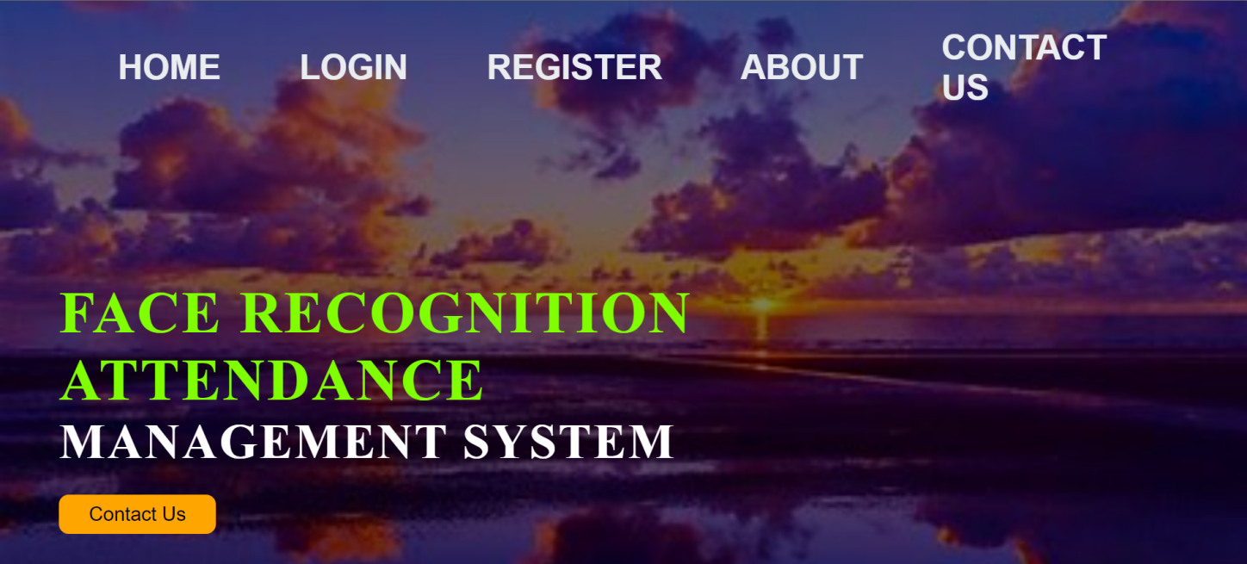

Figure 7.1 HOME page

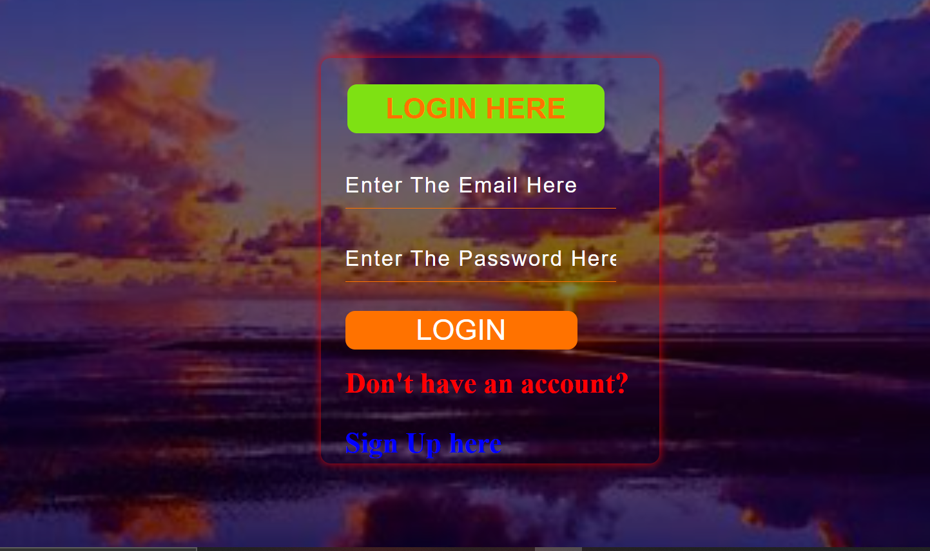

Figure 7.2 LOGIN page

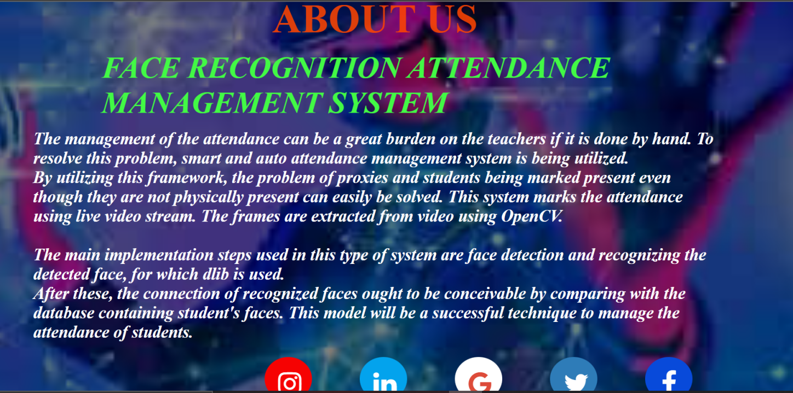

Figure 7.3 ABOUT list page

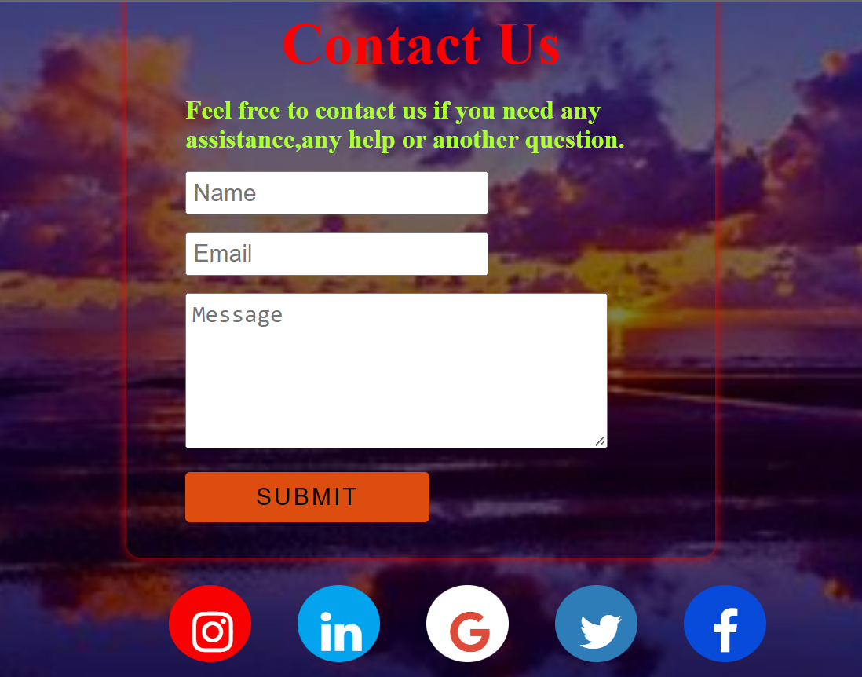

Figure 7.4 CONTACT page

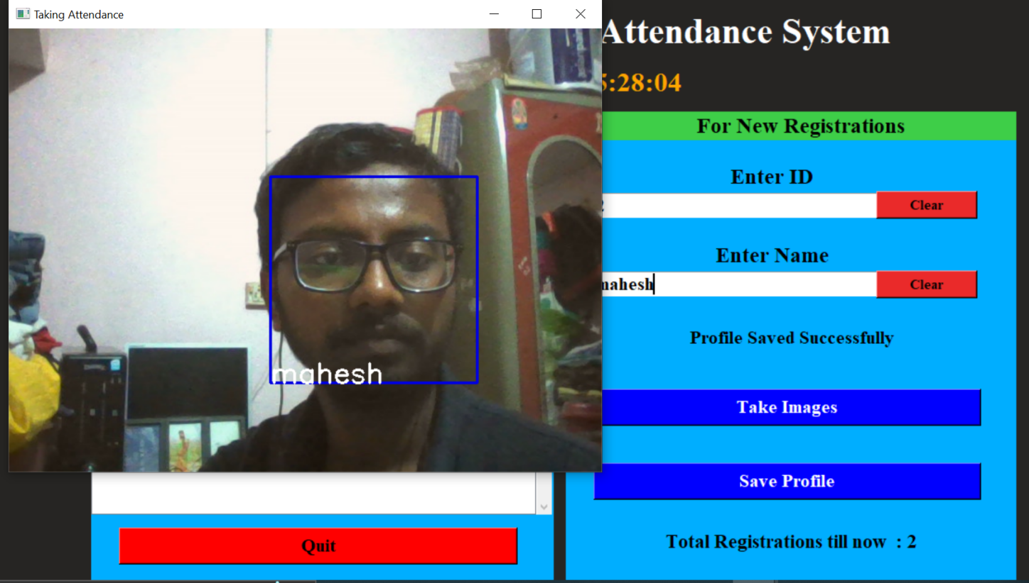

Figure 7.4 ATTENDANCE page

### **CONCLUSION**

With the theoretical inclination of our syllabus it becomes very essential to take the at most advantage of any opportunity of gaining practical experience that comes along. The building blocks of this Major Project “**Face Recognition Attendance Management System**” was one of these opportunities. It gave us the requisite practical knowledge to supplement the already taught theoretical concepts thus making us more competent as a computer engineer. The project from a personal point of view also helped us in understanding the following aspects of project development.

* The planning that goes into implementing a project.
* The importance of proper planning and an organized methodology.
* The key element of team spirit and co-ordination in a successful project.

The project also provides us the opportunity of interacting with our teachers and to gain from their best experience.

Face recognition is an essential feature of Image processing owing to its excellence in many areas. An association of people in an school, colleges, industry,etc for the determination of attendance is one such utilization of face recognition. Keeping and monitoring of attendance records play an important function in the investigation of the execution of any business. The idea of developing an appearance control method is to computerize the common way of using attendance. The advanced face recognition technology helps in improving the performance of the students in attendance of daily activities and analysis with reduced human intervention.

**REFERENCES**

[1] <https://www.w3schools.com/css/default.asp>

[2] <https://www.w3schools.com/html/default.asp>

[3] <https://www.w3schools.com/bootstrap/bootstrap_ver.asp>

[4] [SQL Tutorial (w3schools.com)](https://www.w3schools.com/sql/default.asp)

[5] [W3Schools How TO - Code snippets for HTML, CSS and JavaScript](https://www.w3schools.com/howto/default.asp)

[6[] https://www.fusioninformatics.com/blog/facial-recognition-technology-in-attendance](%5d%20https://www.fusioninformatics.com/blog/facial-recognition-technology-in-attendance)

[7] [haar-cascade · GitHub Topics](https://github.com/topics/haar-cascade)